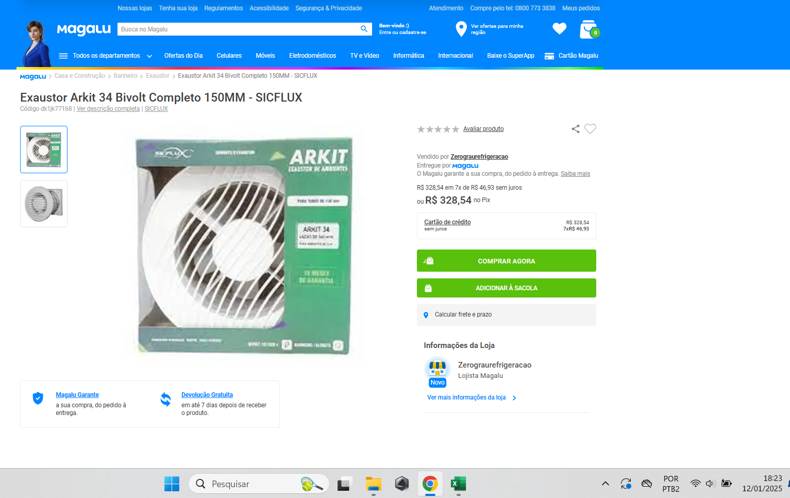
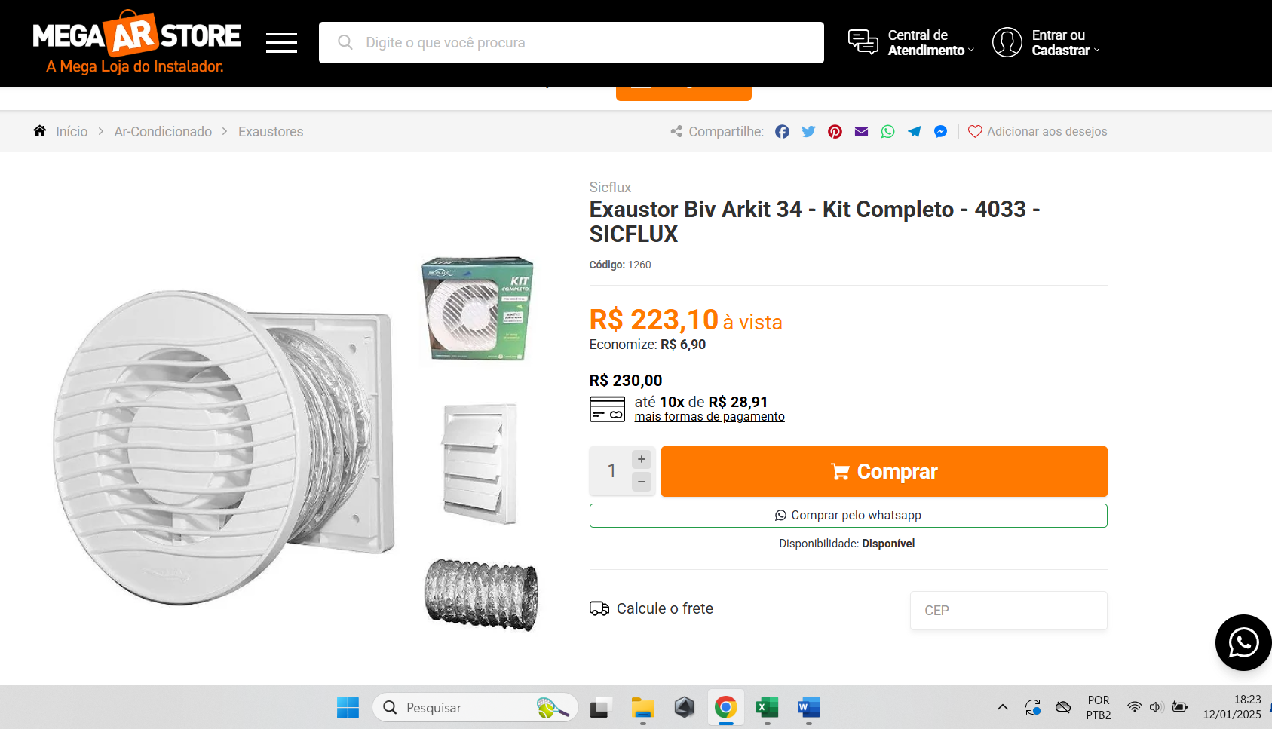
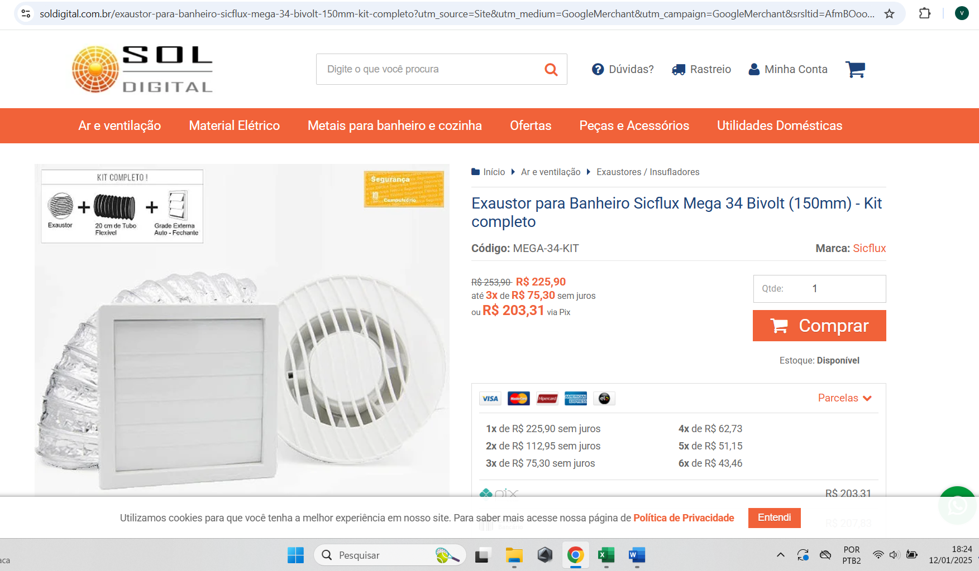
https://www.magazineluiza.com.br/exaustor-arkit-34-bivolt-completo-150mm-sicflux/p/dk1jk77168/cj/exor/?&seller_id=zerograurefrigeracao&utm_source=google&utm_medium=cpc&utm_term=76920&utm_campaign=google_eco_per_ven_pla_ca_sor_3p_ci-cj-fs-b&utm_content=&partner_id=76920&gclsrc=aw.ds&gad_source=4&gclid=CjwKCAiA7Y28BhAnEiwAAdOJUH9OH-Zxao3Fn8Yg-UYMxo6QMNpXv09O9xgmDmfUGByFVf0IQ_A6RxoC-4kQAvD_BwE

https://www.megaarstore.com.br/exaustor-biv-arkit-34-kit-completo-4033-sicflux?utm_source=Site&utm_medium=GoogleShopping&utm_campaign=IntegracaoGoogle&srsltid=AfmBOooh0FH7xPHu7AuE8DxxUIEeozsTW2vW7xdJV27wG5b_Tir7RuAM_kM

https://www.soldigital.com.br/exaustor-para-banheiro-sicflux-mega-34-bivolt-150mm-kit-completo?utm_source=Site&utm_medium=GoogleMerchant&utm_campaign=GoogleMerchant&srsltid=AfmBOooX7RLc64xY01cvGinGd2gj-pxaJazxiUjCVJYhcX4_fuIWtAiW6-s

