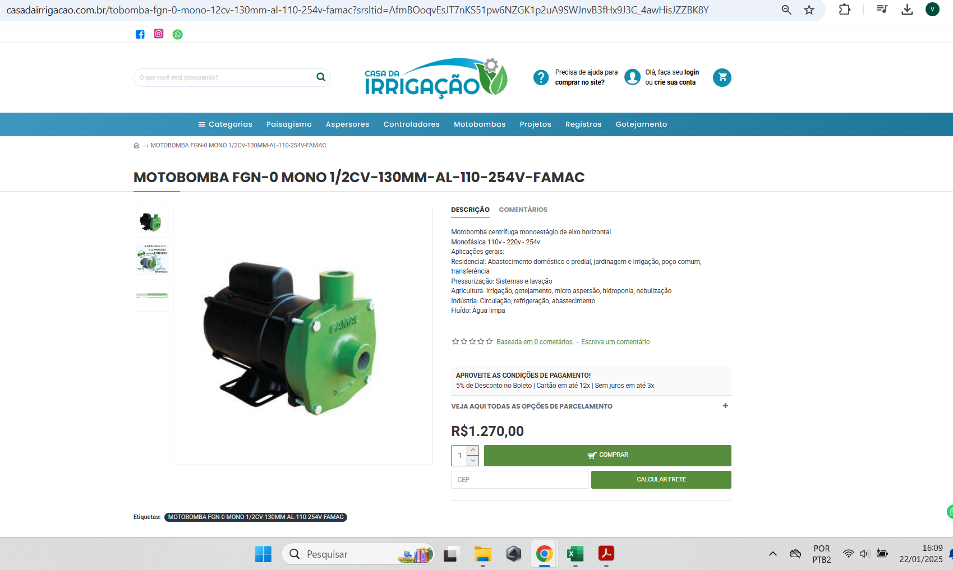
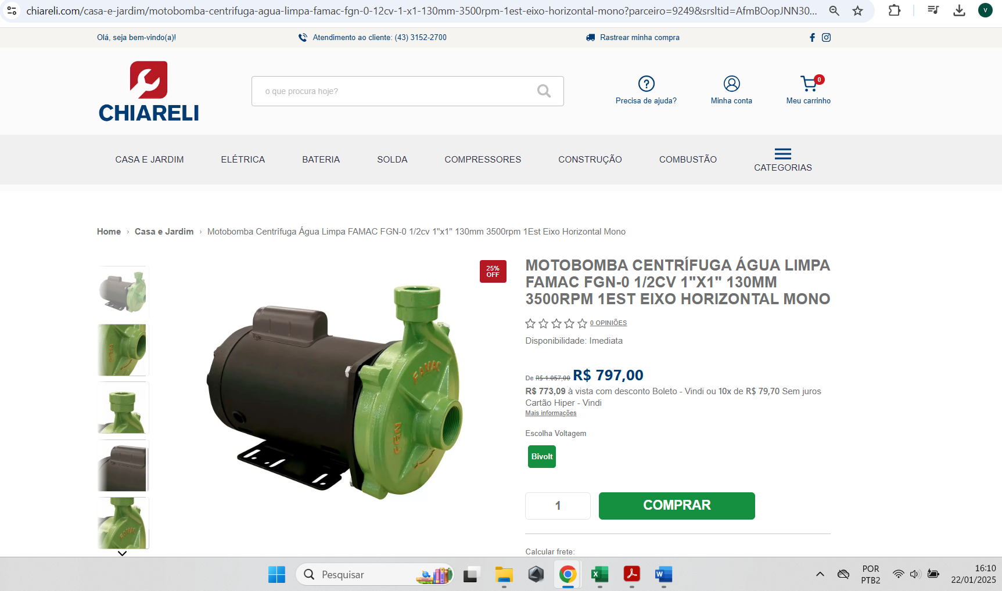
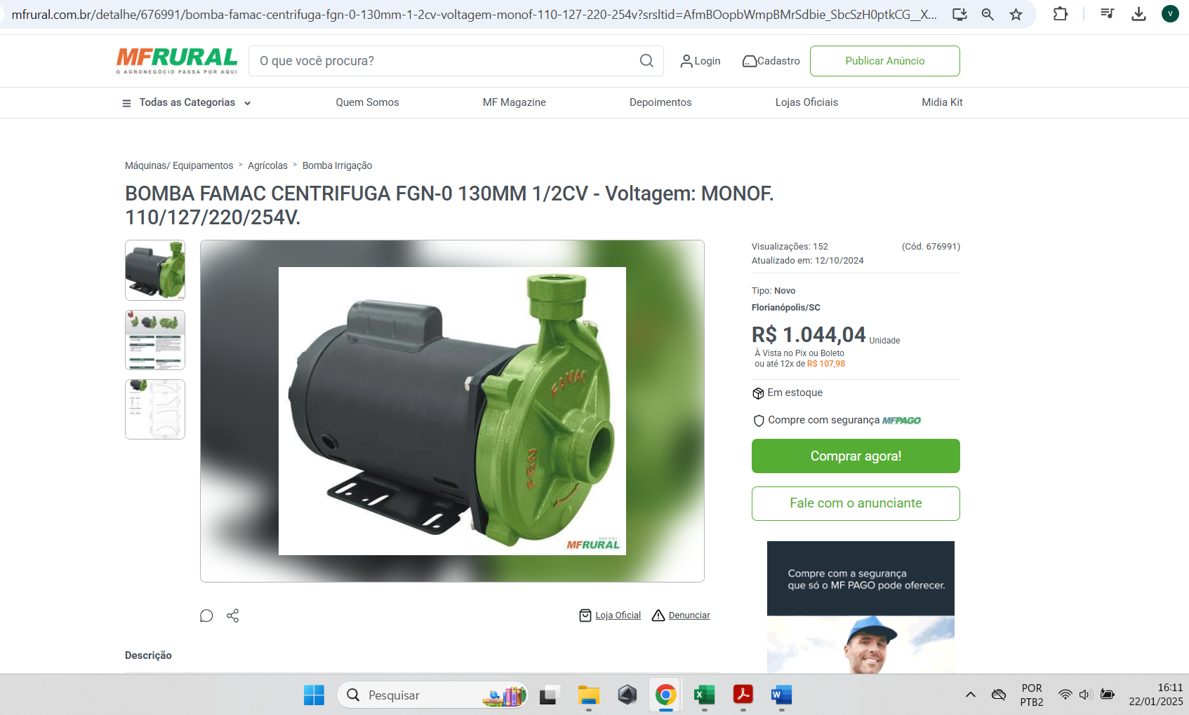
https://www.casadairrigacao.com.br/tobomba-fgn-0-mono-12cv-130mm-al-110-254v-famac?srsltid=AfmBOoqvEsJT7nKS51pw6NZGK1p2uA9SWJnvB3fHx9J3C_4awHisJZZBK8Y

https://www.chiareli.com/casa-e-jardim/motobomba-centrifuga-agua-limpa-famac-fgn-0-12cv-1-x1-130mm-3500rpm-1est-eixo-horizontal-mono?parceiro=9249&srsltid=AfmBOopJNN30W4ujtsz34IelZkGXwmY6ysFAxLlMfh-t4T5eXZx1bRvq-zI&variant_id=2037

https://www.mfrural.com.br/detalhe/676991/bomba-famac-centrifuga-fgn-0-130mm-1-2cv-voltagem-monof-110-127-220-254v?srsltid=AfmBOopbWmpBMrSdbie_SbcSzH0ptkCG__X9b46dCsH-btmaMQTQWTn8g9k

